**Module 3 - PL/SQL Programming**

**Exercise 3: Stored Procedures**

**Scenario 1:** The bank needs to process monthly interest for all savings accounts.

**Question:** Write a stored procedure **ProcessMonthlyInterest** that calculates and updates the balance of all savings accounts by applying an interest rate of 1% to the current balance.

**QUERY:**

CREATE OR REPLACE PROCEDURE ProcessMonthlyInterest AS

v_new_balance NUMBER;

BEGIN

FOR acc IN (

SELECT AccountID, Balance

FROM Accounts

WHERE AccountType = 'Savings'

) LOOP

v_new_balance := acc.Balance * 1.01;

UPDATE Accounts

SET Balance = v_new_balance,

LastModified = SYSDATE

WHERE AccountID = acc.AccountID;

DBMS_OUTPUT.PUT_LINE('Updated AccountID ' || acc.AccountID || ' New Balance: ' || v_new_balance);

END LOOP;

END;

/

EXEC ProcessMonthlyInterest;

**OUTPUT:**

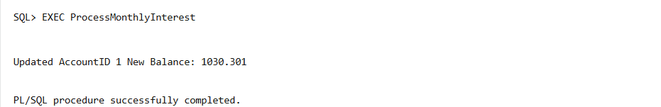

**Scenario 2:** The bank wants to implement a bonus scheme for employees based on their performance.

**Question:** Write a stored procedure **UpdateEmployeeBonus** that updates the salary of employees in a given department by adding a bonus percentage passed as a parameter.

**QUERY:**

CREATE OR REPLACE PROCEDURE UpdateEmployeeBonus (

p_department IN VARCHAR2,

p_bonus_percent IN NUMBER

) AS

BEGIN

FOR emp IN (

SELECT EmployeeID, Name, Salary

FROM Employees

WHERE Department = p_department

) LOOP

DECLARE

v_new_salary NUMBER;

BEGIN

v_new_salary := emp.Salary + (emp.Salary * p_bonus_percent / 100);

UPDATE Employees

SET Salary = v_new_salary

WHERE EmployeeID = emp.EmployeeID;

DBMS_OUTPUT.PUT_LINE(

'EmployeeID: ' || emp.EmployeeID ||

', Name: ' || emp.Name ||

', New Salary: ' || v_new_salary

);

END;

END LOOP;

END;

/

EXEC UpdateEmployeeBonus(‘IT’, 10);

**OUTPUT:**

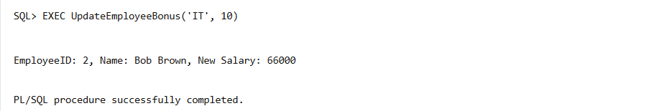

**Scenario 3:** Customers should be able to transfer funds between their accounts.

**Question:** Write a stored procedure **TransferFunds** that transfers a specified amount from one account to another, checking that the source account has sufficient balance before making the transfer.

**QUERY:**

CREATE OR REPLACE PROCEDURE TransferFunds (

p_from_account_id IN NUMBER,

p_to_account_id IN NUMBER,

p_amount IN NUMBER

) AS

v_from_balance NUMBER;

BEGIN

SELECT Balance INTO v_from_balance

FROM Accounts

WHERE AccountID = p_from_account_id;

IF v_from_balance < p_amount THEN

DBMS_OUTPUT.PUT_LINE('Insufficient balance. Transfer failed.');

RETURN;

END IF;

UPDATE Accounts

SET Balance = Balance - p_amount

WHERE AccountID = p_from_account_id;

UPDATE Accounts

SET Balance = Balance + p_amount

WHERE AccountID = p_to_account_id;

DBMS_OUTPUT.PUT_LINE('Transfer successful.');

END;

/

EXEC TransferFunds(1, 2, 200);

**OUTPUT:**

